Acute upper gastrointestinal
bleeding overview
1 Adult or young person (16 years and older) with upper
gastrointestinal bleeding
No additional information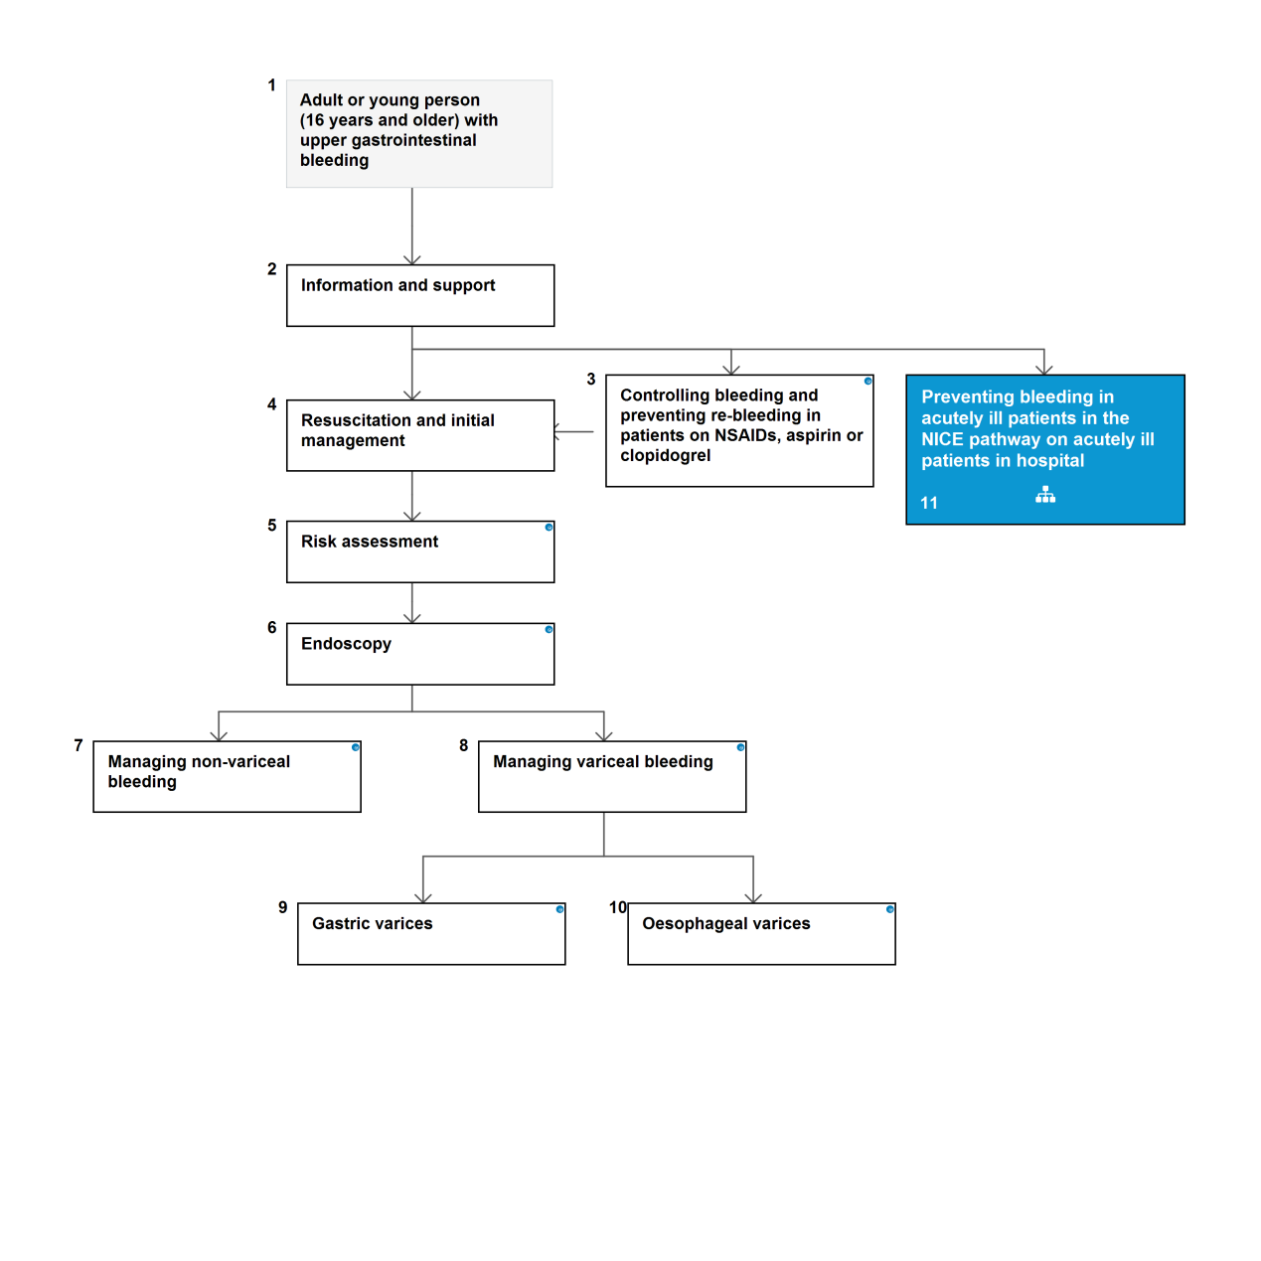

2 Information and support
Establish good communication between clinical staff and patients and their family and carers at the time of presentation, throughout their time in hospital and following discharge. This should include:
- giving verbal information that is recorded in medical records
- different members of clinical teams providing consistent information
- providing written information where appropriate
- ensuring patients and their families and carers receive consistent information.
3
Controlling bleeding and preventing re-bleeding in patients on NSAIDs, aspirin or clopidogrel
Continue low-dose aspirin for secondary prevention of vascular events in patients with upper gastrointestinal bleeding in whom haemostasis has been achieved.

Stop other non-steroidal anti-inflammatory drugs (including cyclooxygenase-2 [COX-2] inhibitors) during the acute phase in patients presenting with upper gastrointestinal bleeding.

Discuss the risks and benefits of continuing clopidogrel (or any other thienopyridine antiplatelet agents) in patients with upper gastrointestinal bleeding with the appropriate specialist (for example, a cardiologist or a stroke specialist) and with the patient.

4 Resuscitation and initial management
Transfuse patients with massive bleeding with blood, platelets and clotting factors in line with local protocols for managing massive bleeding.
Base decisions on blood transfusion on the full clinical picture, recognising that over-transfusion may be as damaging as under-transfusion.
Do not offer platelet transfusion to patients who are not actively bleeding and are haemodynamically stable.
Offer platelet transfusion to patients who are actively bleeding and have a platelet count of less than 50 x 109/litre.
Offer fresh frozen plasma to patients who have either:
a fibrinogen level of less than 1 g/litre, or
a prothrombin time (international normalised ratio) or activated partial thromboplastin time greater than 1.5 times normal.
Offer prothrombin complex concentrate to patients who are taking warfarin and actively bleeding.
Treat patients who are taking warfarin and whose upper gastrointestinal bleeding has stopped in line with local warfarin protocols.
Do not use recombinant factor Vlla except when all other methods have failed.

5 Risk assessment
Use the following formal risk assessment scores for all patients with acute upper gastrointestinal bleeding:
the Blatchford score at first assessment, and
the full Rockall score after endoscopy.
Consider early discharge for patients with a pre-endoscopy Blatchford score of 0.

Quality standards
The following quality statement is relevant to this part of the pathway.
1. Risk assessment
6 Endoscopy
Offer endoscopy to unstable patients with severe acute upper gastrointestinal bleeding immediately after resuscitation.
Offer endoscopy within 24 hours of admission to all other patients with upper gastrointestinal bleeding.
Units seeing more than 330 cases a year should offer daily endoscopy lists. Units seeing fewer than 330 cases a year should arrange their service according to local circumstances.
2. Immediate endoscopy for people who are haemodynamically unstable
3. Endoscopy within 24 hours for people who are haemodynamically stable

7 Managing non-variceal bleeding

Endoscopic treatment
Do not use adrenaline as monotherapy for the endoscopic treatment of non-variceal upper gastrointestinal bleeding.
For the endoscopic treatment of non-variceal upper gastrointestinal bleeding, use one of the following:
a mechanical method (for example, clips) with or without adrenaline
thermal coagulation with adrenaline fibrin or thrombin with adrenaline.

Proton pump inhibitors
Do not offer acid-suppression drugs (proton pump inhibitors or H2-receptor antagonists) before endoscopy to patients with suspected non-variceal upper gastrointestinal bleeding.
Offer proton pump inhibitors to patients with non-variceal upper gastrointestinal bleeding and stigmata of recent haemorrhage shown at endoscopy.

Treatment after first or failed endoscopic treatment
Consider a repeat endoscopy, with treatment as appropriate, for all patients at high risk of rebleeding,
particularly if there is doubt about adequate haemostasis at the first endoscopy.
Offer a repeat endoscopy to patients who re-bleed with a view to further endoscopic treatment or emergency surgery.
Offer interventional radiology to unstable patients who re-bleed after endoscopic treatment.
Refer urgently for surgery if interventional radiology is not promptly available.

Quality standards
The following quality statements are relevant to this part of the pathway.
4. Endoscopic treatment for non-variceal bleeding
5. Treatment of non-variceal bleeding after first or failed endoscopic treatment

Resources
The following implementation tools are relevant to this part of the pathway.
Acute upper gastrointestinal bleeding: non-variceal clinical audit tool
Acute upper gastrointestinal bleeding: non-variceal electronic audit tool
8
Managing variceal bleeding
Offer terlipressin1 to patients with suspected variceal bleeding at presentation. Stop treatment after definitive haemostasis has been achieved, or after 5 days, unless there is another indication for its use.
Offer prophylactic antibiotic therapy at presentation to patients with suspected or confirmed variceal bleeding.

Quality standards
The following quality statement is relevant to this part of the pathway.
6. Prophylactic antibiotic therapy for variceal bleeding

Gastric varices
Offer endoscopic injection of N-butyl-2-cyanoacrylate to patients with upper gastrointestinal bleeding from gastric varices.
Offer TIPS if bleeding from gastric varices is not controlled by endoscopic injection of Nbutyl- 2-cyanoacrylate.

Quality standards
The following quality statements are relevant to this part of the pathway.
8. N-butyl-2-cyanoacrylate for gastric variceal bleeding
9. Management of variceal bleeding using transjugular intrahepatic portosystemic shunts (TIPS)

10 Oesophageal varices
Use band ligation in patients with upper gastrointestinal bleeding from oesophageal varices.
Consider TIPS if bleeding from oesophageal varices is not controlled by band ligation.
Quality standards
The following quality statements are relevant to this part of the pathway.
7. Band ligation for oesophageal variceal bleeding
9. Management of variceal bleeding using transjugular intrahepatic portosystemic shunts
(TIPS)

1

